# **Introduction to Performance Troubleshooting [1 of 7] | Azure SQL for beginners**

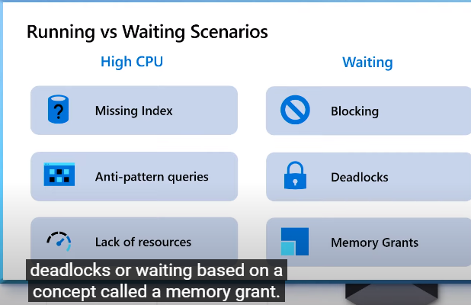

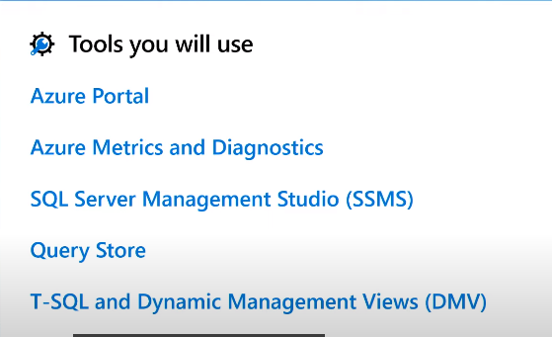

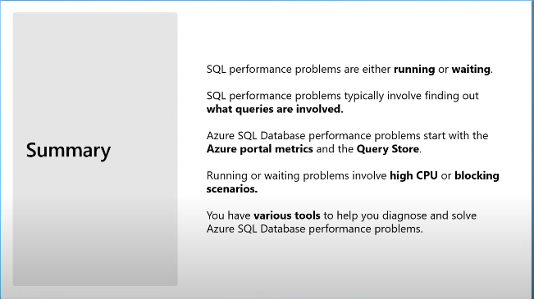

# **High CPU due to a Missing Index [2 of 7] | Azure SQL for beginners**

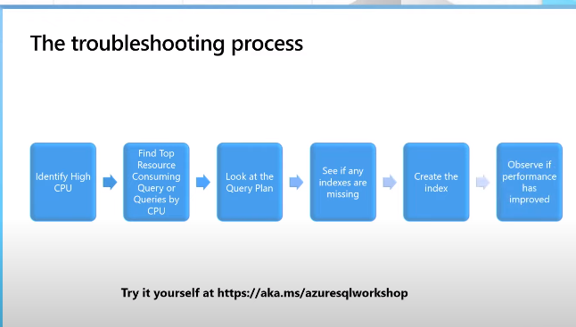

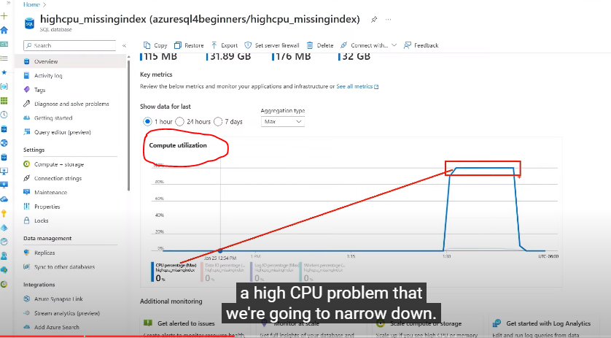

After creating a missing index as per the Sql server recommendation (took recommendation from Query store), below is the improvement

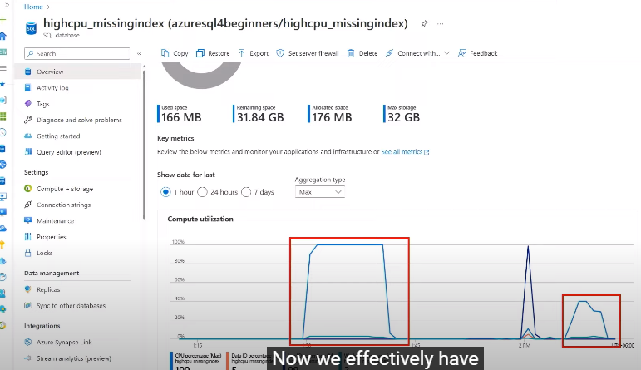

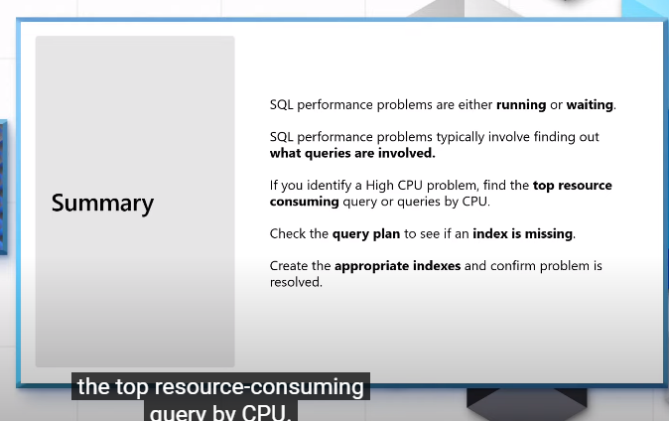

# **High CPU due to anti-pattern queries [3 of 7] | Azure SQL for beginners**

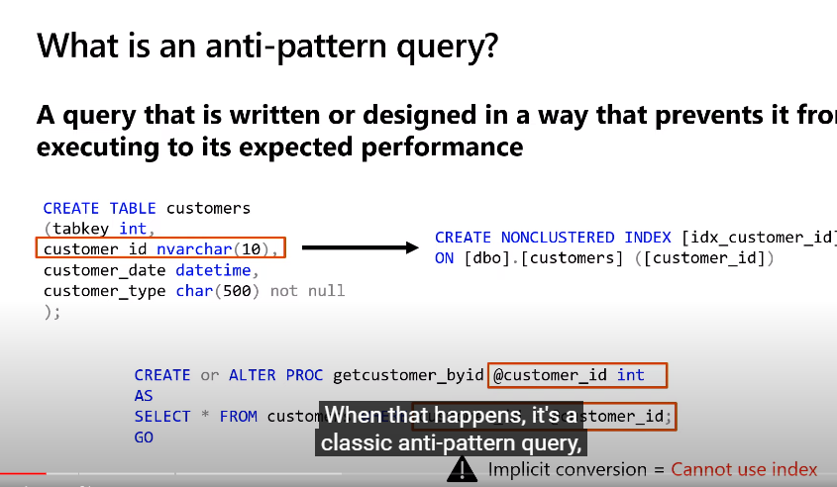

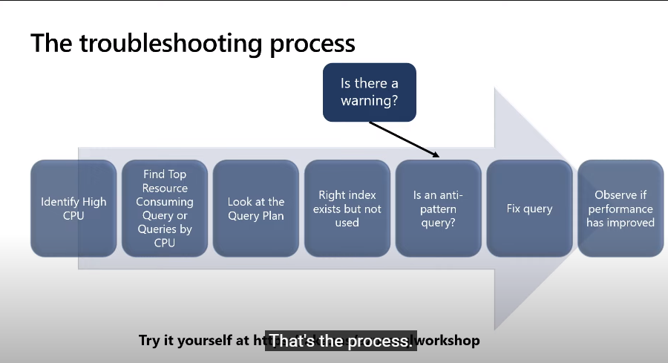

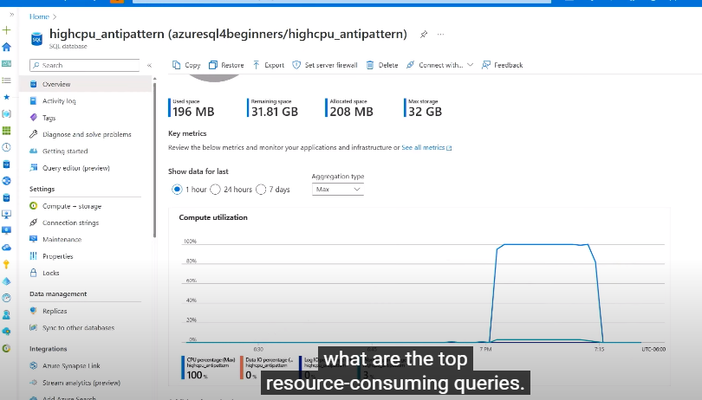

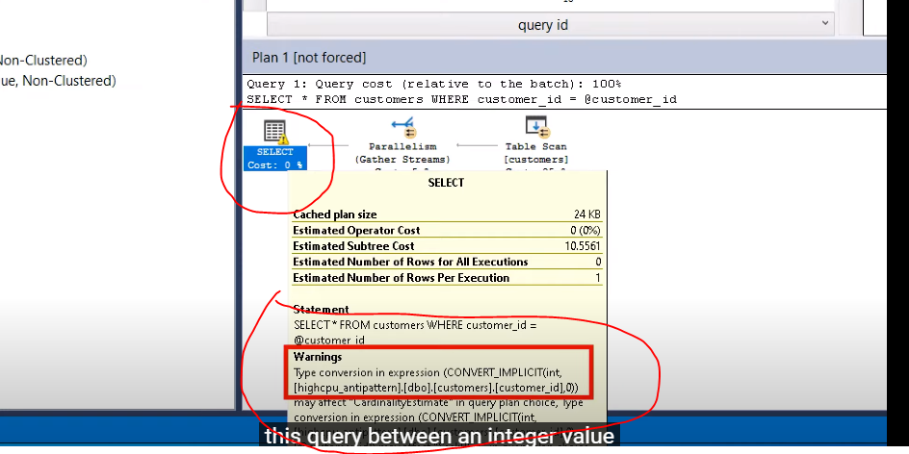

Carefully look at warning symbol in the execution plan

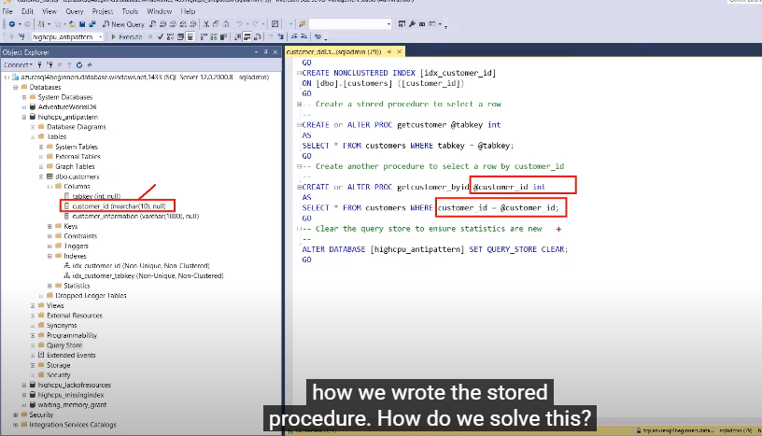

In the above snip, we can see on the left-hand side, Customer id column is created in nvarchar, but the SP is created using INT .. This will cause anti pattern query …

Once you have created the SP using correct column type, your execution plan will change as shown below (This is how performance is improving)

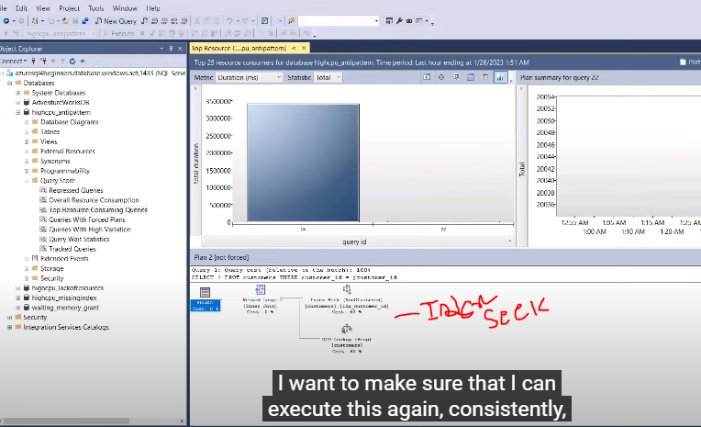

After implementing the fix, see how CPU utilization is improved

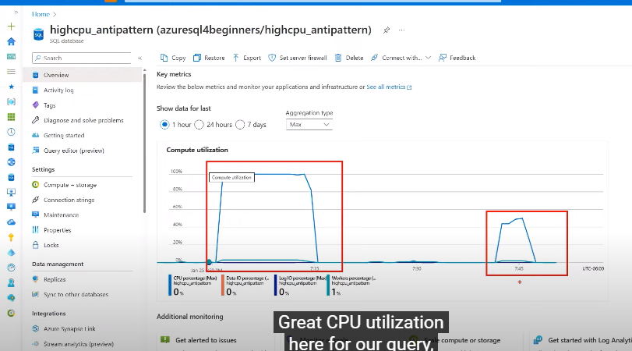

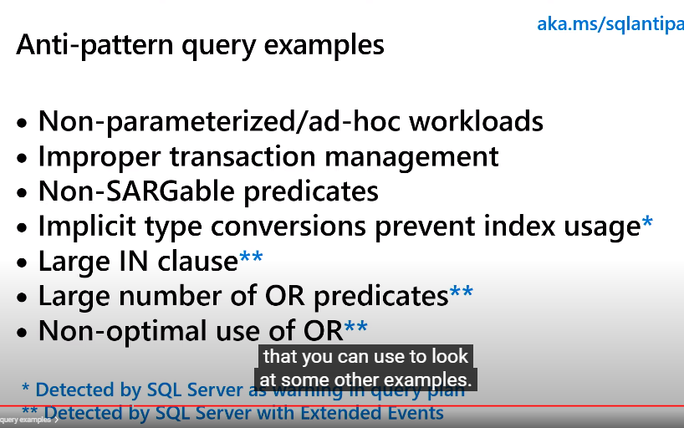

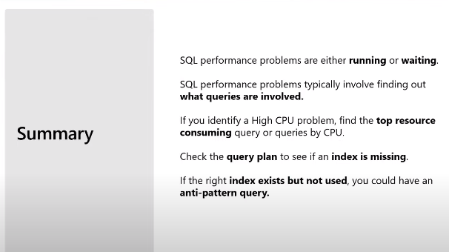

**Indexes** are created on tables or views. Indexes can be likened to a book directory and improve the speed of searches. Some examples of different types of indexes are clustered indexes, non-cluster indexes and column store indexes.

An **index scan** is when SQL Server **reads all the data in the index pages**. The cost of an index scan is very expensive for the SQL Server Engine.

An **index seek** is when SQL Server **reads only matching data in the index pages**. This method is more efficient for query performance because it will reduce IO and time consumption.

# **High CPU due to lack of resources [4 of 7] | Azure SQL for beginners**

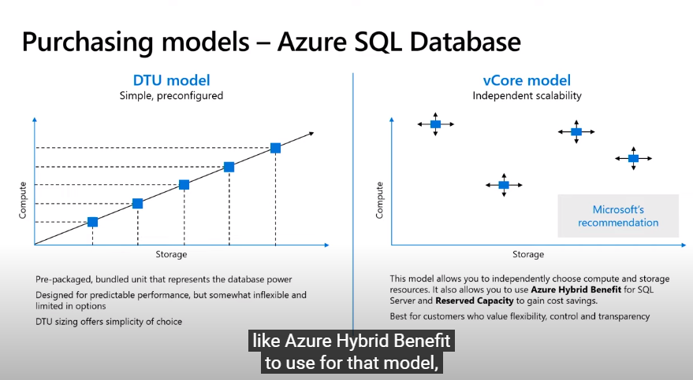

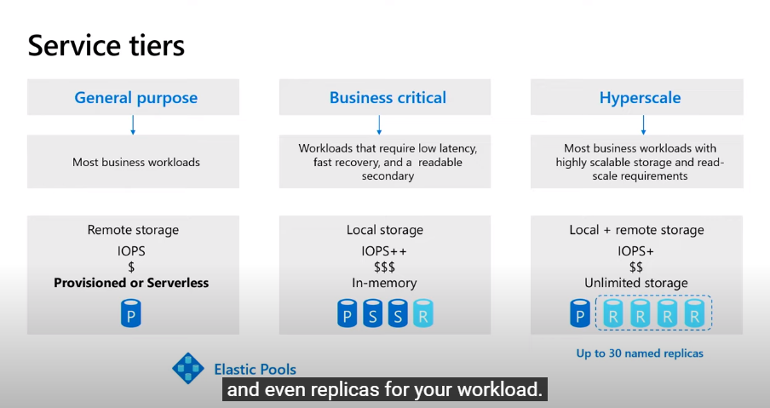

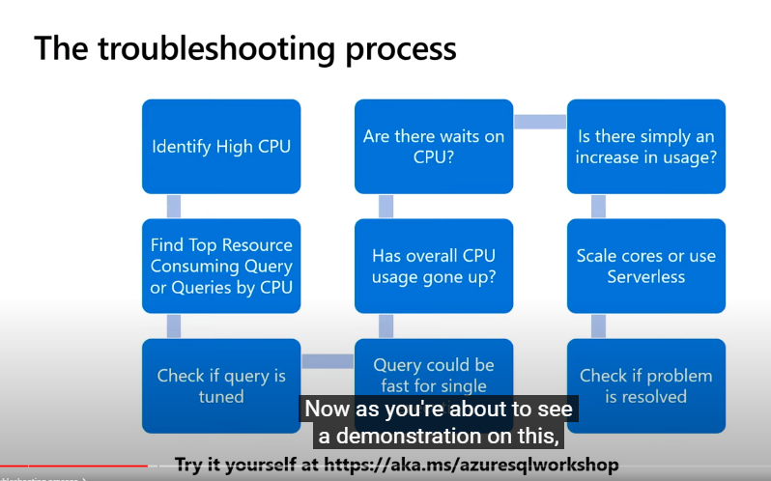

Adding more cores will fix the issue, if you are not sure how many cores to increase ..serverless model help us to solve this High CPU problem due to lack of resources

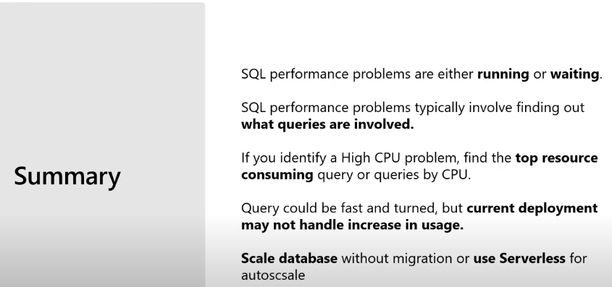

# **Waiting due to Blocking [5 of 7] | Azure SQL for beginners**

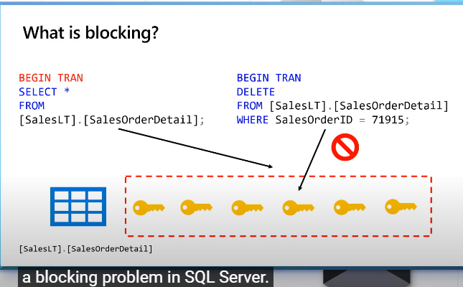

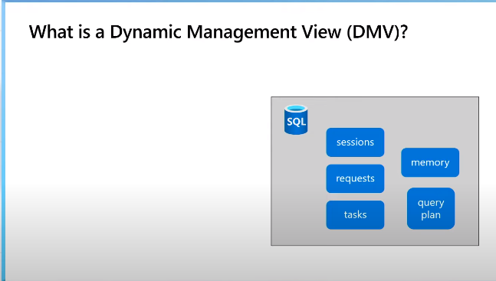

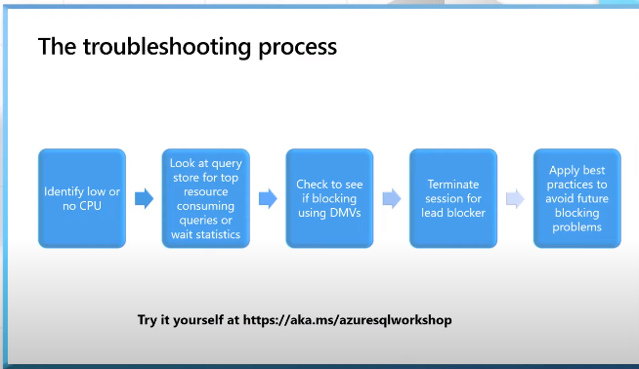

Steps in troubleshooting:

1. Identify the main blocking session (head blocker)
2. Find the query and transaction that is causing the blocking (what is holding locks for a prolonged period)
3. Analyze/understand why the prolonged blocking occurs
4. Resolve blocking issue by redesigning query and transaction

**Tsql to identify blocking: (https://learn.microsoft.com/en-in/azure/azure-sql/database/understand-resolve-blocking?view=azuresql-db)**

WITH cteHead ( session_id,request_id,wait_type,wait_resource,last_wait_type,is_user_process,request_cpu_time

,request_logical_reads,request_reads,request_writes,wait_time,blocking_session_id,memory_usage

,session_cpu_time,session_reads,session_writes,session_logical_reads

,percent_complete,est_completion_time,request_start_time,request_status,command

,plan_handle,sql_handle,statement_start_offset,statement_end_offset,most_recent_sql_handle

,session_status,group_id,query_hash,query_plan_hash)

AS ( SELECT sess.session_id, req.request_id, LEFT (ISNULL (req.wait_type, ''), 50) AS 'wait_type'

, LEFT (ISNULL (req.wait_resource, ''), 40) AS 'wait_resource', LEFT (req.last_wait_type, 50) AS 'last_wait_type'

, sess.is_user_process, req.cpu_time AS 'request_cpu_time', req.logical_reads AS 'request_logical_reads'

, req.reads AS 'request_reads', req.writes AS 'request_writes', req.wait_time, req.blocking_session_id,sess.memory_usage

, sess.cpu_time AS 'session_cpu_time', sess.reads AS 'session_reads', sess.writes AS 'session_writes', sess.logical_reads AS 'session_logical_reads'

, CONVERT (decimal(5,2), req.percent_complete) AS 'percent_complete', req.estimated_completion_time AS 'est_completion_time'

, req.start_time AS 'request_start_time', LEFT (req.status, 15) AS 'request_status', req.command

, req.plan_handle, req.[sql_handle], req.statement_start_offset, req.statement_end_offset, conn.most_recent_sql_handle

, LEFT (sess.status, 15) AS 'session_status', sess.group_id, req.query_hash, req.query_plan_hash

FROM sys.dm_exec_sessions AS sess

LEFT OUTER JOIN sys.dm_exec_requests AS req ON sess.session_id = req.session_id

LEFT OUTER JOIN sys.dm_exec_connections AS conn on conn.session_id = sess.session_id

)

, cteBlockingHierarchy (head_blocker_session_id, session_id, blocking_session_id, wait_type, wait_duration_ms,

wait_resource, statement_start_offset, statement_end_offset, plan_handle, sql_handle, most_recent_sql_handle, [Level])

AS ( SELECT head.session_id AS head_blocker_session_id, head.session_id AS session_id, head.blocking_session_id

, head.wait_type, head.wait_time, head.wait_resource, head.statement_start_offset, head.statement_end_offset

, head.plan_handle, head.sql_handle, head.most_recent_sql_handle, 0 AS [Level]

FROM cteHead AS head

WHERE (head.blocking_session_id IS NULL OR head.blocking_session_id = 0)

AND head.session_id IN (SELECT DISTINCT blocking_session_id FROM cteHead WHERE blocking_session_id != 0)

UNION ALL

SELECT h.head_blocker_session_id, blocked.session_id, blocked.blocking_session_id, blocked.wait_type,

blocked.wait_time, blocked.wait_resource, h.statement_start_offset, h.statement_end_offset,

h.plan_handle, h.sql_handle, h.most_recent_sql_handle, [Level] + 1

FROM cteHead AS blocked

INNER JOIN cteBlockingHierarchy AS h ON h.session_id = blocked.blocking_session_id and h.session_id!=blocked.session_id --avoid infinite recursion for latch type of blocking

WHERE h.wait_type COLLATE Latin1_General_BIN NOT IN ('EXCHANGE', 'CXPACKET') or h.wait_type is null

)

SELECT bh.*, txt.text AS blocker_query_or_most_recent_query

FROM cteBlockingHierarchy AS bh

OUTER APPLY sys.dm_exec_sql_text (ISNULL ([sql_handle], most_recent_sql_handle)) AS txt;

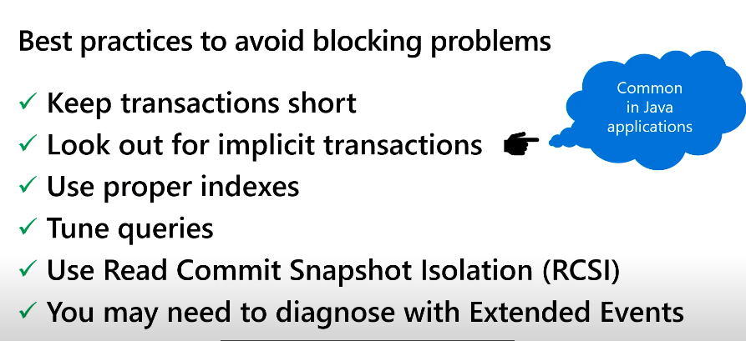

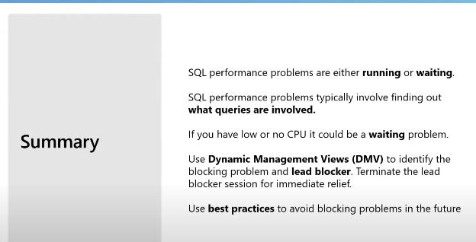

# **Waiting due to deadlocks [6 of 7] | Azure SQL for beginners**

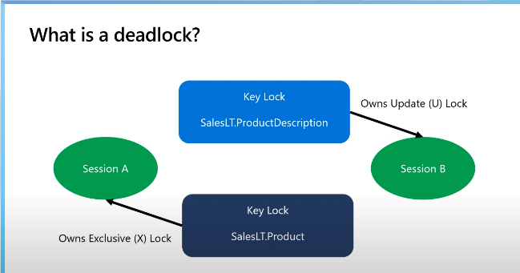

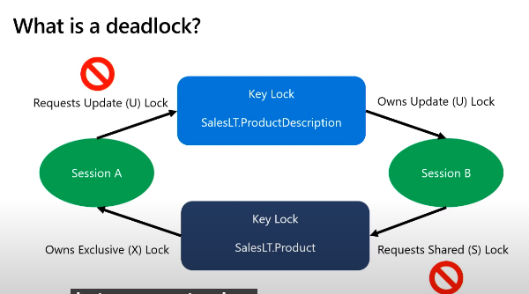

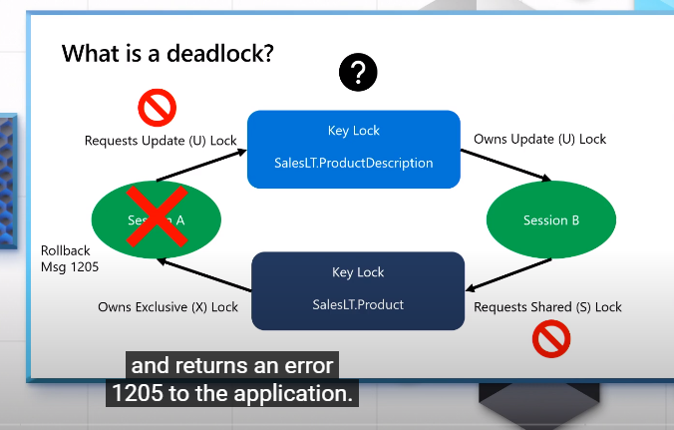

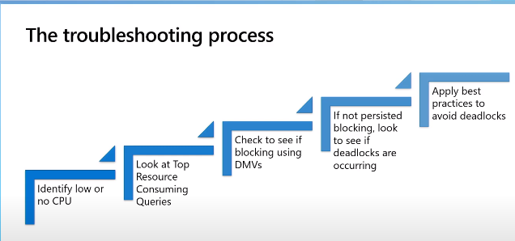

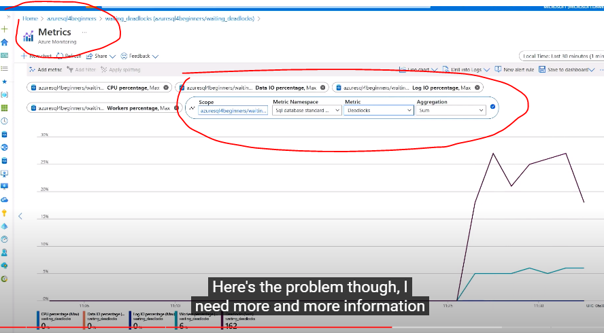

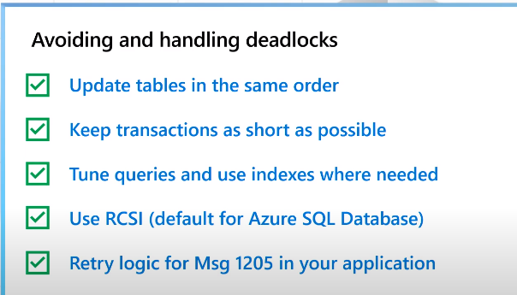

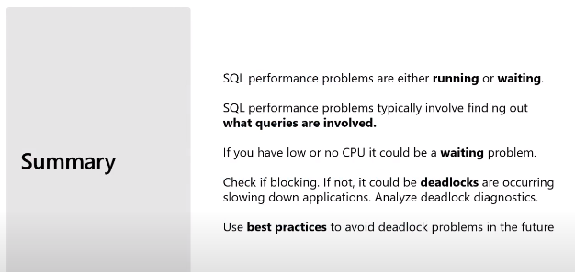

# **Waiting due to memory grants [7 of 7] | Azure SQL for beginners**

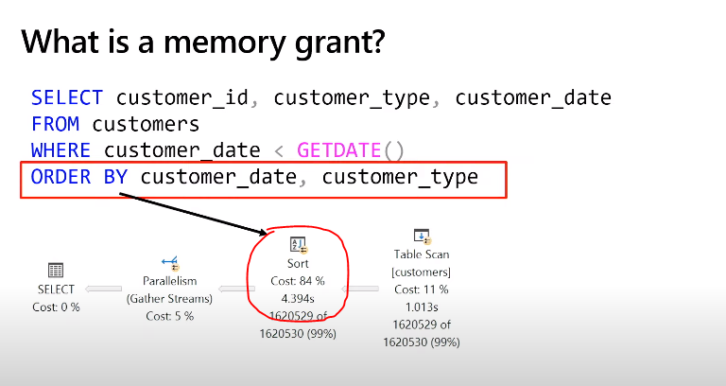

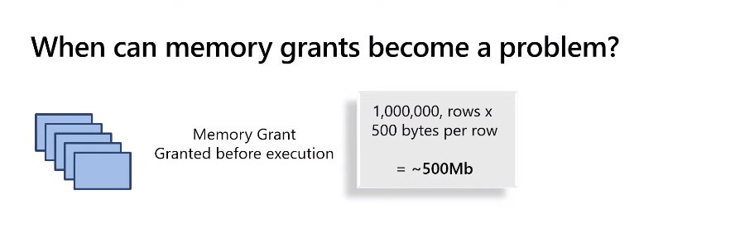

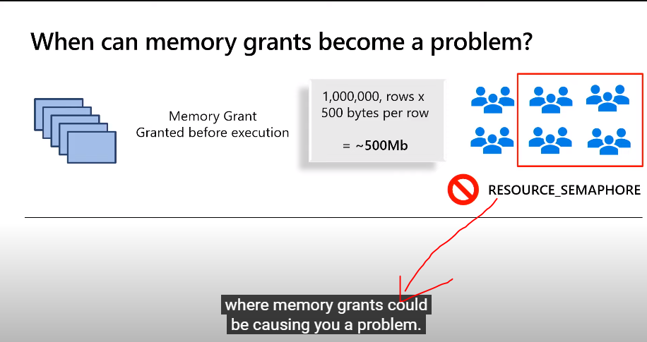

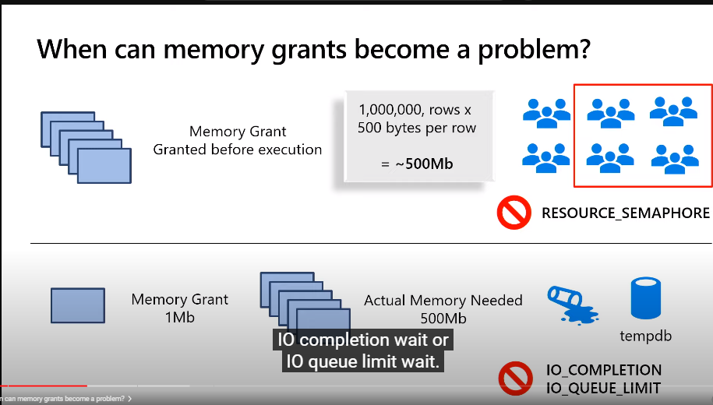

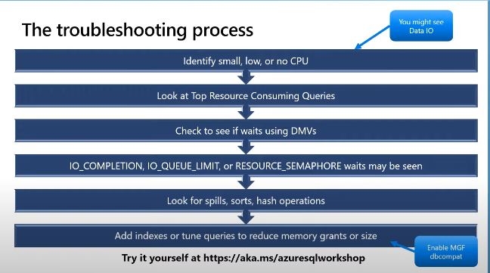

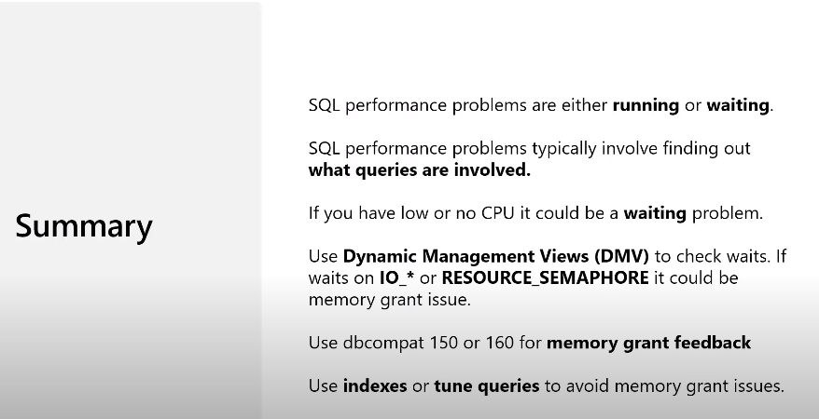

Tsql to check memory related :

SELECT CONVERT (varchar(30), GETDATE(), 121) as runtime

, r.session_id

, r.wait_time

, r.wait_type

, mg.request_time

, mg.grant_time

, mg.requested_memory_kb

/ 1024 requested_memory_mb

, mg.granted_memory_kb

/ 1024 AS granted_memory_mb

, mg.required_memory_kb

/ 1024 AS required_memory_mb

, max_used_memory_kb

/ 1024 AS max_used_memory_mb

, rs.pool_id as resource_pool_id

, mg.query_cost

, mg.timeout_sec

, mg.resource_semaphore_id

, mg.wait_time_ms AS memory_grant_wait_time_ms

, CASE mg.is_next_candidate

WHEN 1 THEN 'Yes'

WHEN 0 THEN 'No'

ELSE 'Memory has been granted'

END AS 'Next Candidate for Memory Grant'

, r.command

, ltrim(rtrim(replace(replace (substring (q.text, 1, 1000), char(10), ' '), char(13), ' '))) [text]

, rs.target_memory_kb

/ 1024 AS server_target_grant_memory_mb

, rs.max_target_memory_kb

/ 1024 AS server_max_target_grant_memory_mb

, rs.total_memory_kb

/ 1024 AS server_total_resource_semaphore_memory_mb

, rs.available_memory_kb

/ 1024 AS server_available_memory_for_grants_mb

, rs.granted_memory_kb

/ 1024 AS server_total_granted_memory_mb

, rs.used_memory_kb

/ 1024 AS server_used_granted_memory_mb

, rs.grantee_count AS successful_grantee_count

, rs.waiter_count AS grant_waiters_count

, rs.timeout_error_count

, rs.forced_grant_count

, mg.dop

, r.blocking_session_id

, r.cpu_time

, r.total_elapsed_time

, r.reads

, r.writes

, r.logical_reads

, r.row_count

, s.login_time

, d.name

, s.login_name

, s.host_name

, s.nt_domain

, s.nt_user_name

, s.status

, c.client_net_address

, s.program_name

, s.client_interface_name

, s.last_request_start_time

, s.last_request_end_time

, c.connect_time

, c.last_read

, c.last_write

, qp.query_plan

FROM sys.dm_exec_requests r

INNER JOIN sys.dm_exec_connections c

ON r.connection_id = c.connection_id

INNER JOIN sys.dm_exec_sessions s

ON c.session_id = s.session_id

INNER JOIN sys.databases d

ON r.database_id = d.database_id

INNER JOIN sys.dm_exec_query_memory_grants mg

ON s.session_id = mg.session_id

INNER JOIN sys.dm_exec_query_resource_semaphores rs

ON mg.resource_semaphore_id = rs.resource_semaphore_id

CROSS APPLY sys.dm_exec_sql_text (r.sql_handle ) AS q

CROSS APPLY sys.dm_exec_query_plan(mg.plan_handle) qp

OPTION (MAXDOP 1, LOOP JOIN )